❖ Query 1.1: Find the name and age of all the characters from the movies
directed by Satyajit Ray.

➵ 1.1.1: Without Join or Cartesian Product (using Subqueries only)
SELECT character_Name,movie_characters.Age FROM movie_characters
WHERE Character_ID IN (SELECT character_ID from movie_character_relationship
WHERE Movie_ID IN (SELECT Movie_ID
FROM movie
WHERE movie.Director_ID = (SELECT Person_ID FROM director
WHERE director.Director_Name="Saytajit Ray")));

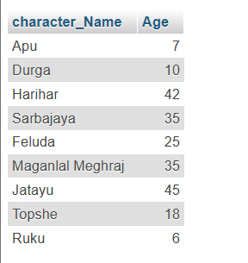

➵ 1.1.2: Using Join (Without using any Subqueries)
SELECT Character_Name,Age, R.Movie_ID, D.Director_Name, M.Movie_Name
FROM movie_characters AS C JOIN movie_character_relationship AS R
ON C.Character_ID = R.Character_ID
JOIN movie as M ON M.Movie_ID=R.Movie_ID
JOIN Director as D ON D.Person_ID=M.Director_ID
WHERE D.Director_Name = "Saytajit Ray";
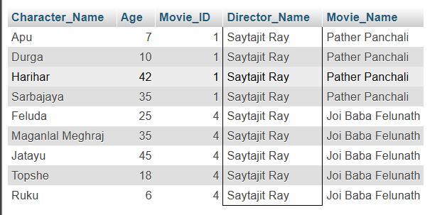

❖ Query 1.2: Find the movie genre with highest average IMDb rating.
SELECT Genre,ROUND(AVG(IMDB_Rating),2) AVG_IMDB
FROM movie
GROUP BY Genre
HAVING AVG_IMDB = (SELECT MAX(AVG_IMDB) FROM (SELECT Genre,ROUND(AVG(IMDB_Rating),2) AVG_IMDB FROM movie GROUP BY Genre) as T);


❖ Query 1.3: Find the name, year of release, IMDB rating of all the movies of
the director who created the iconic character “MaganLal MeghRaj”.
SELECT Movie_name,Year,IMDB_Rating
FROM movie JOIN Director ON Director.Person_ID=Movie.Director_ID
WHERE Director.Person_ID =(SELECT D.Person_ID
FROM movie AS M
JOIN director AS D ON D.Person_ID = M.Director_ID
JOIN movie_character_relationship AS R ON R.Movie_ID = M.Movie_ID
JOIN movie_characters AS C ON C.Character_ID = R.Character_ID
WHERE c.Character_Name = "Maganlal Meghraj");
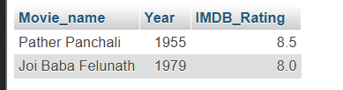
❖ Query 1.4: Find all movies featuring at least four cast members.
SELECT movie.Movie_Name, movie.Movie_ID, COUNT(*) AS Character_Count
FROM movie_character_relationship JOIN movie
ON movie.Movie_ID = movie_character_relationship.Movie_ID
GROUP BY Movie_ID
HAVING Character_Count >= 4;
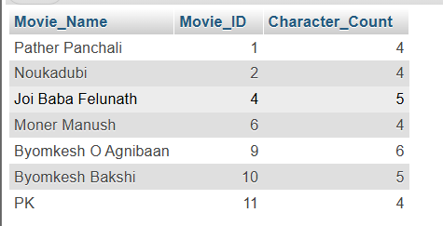

❖ Query 1.5: Find the name, genre, year of release and IMDB rating of the
movie with the largest cast.
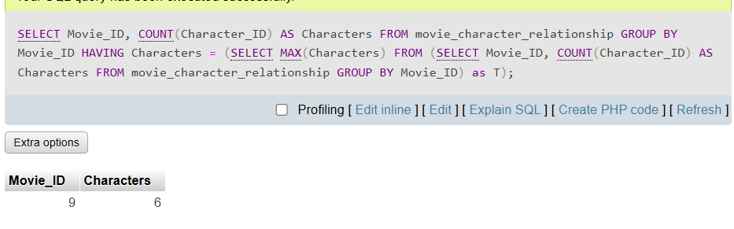
SELECT movie.Movie_Name, movie.Genre, movie.Year, movie.IMDB_Rating, movie.Movie_ID, COUNT(*) AS Character_Count
FROM movie_character_relationship JOIN movie
ON movie.Movie_ID = movie_character_relationship.Movie_ID
GROUP BY Movie_ID
HAVING Character_Count = (SELECT MAX(Characters)
FROM (SELECT Movie_ID, COUNT(Character_ID) AS Characters
FROM movie_character_relationship
GROUP BY Movie_ID) as T);


